Unit 3 Discussion 2: Multimedia
Name
Institution

Unit 3 Discussion 2: Multimedia

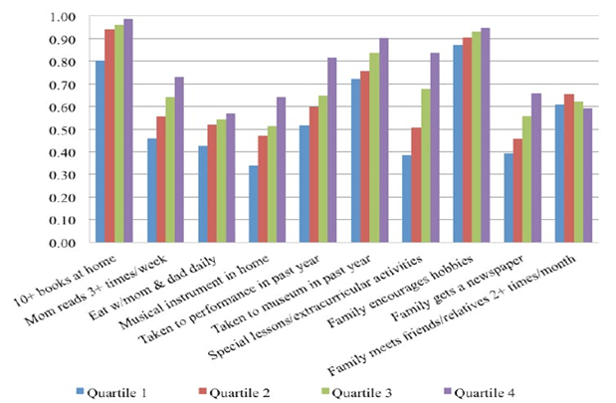
(Caucutt, 2015)

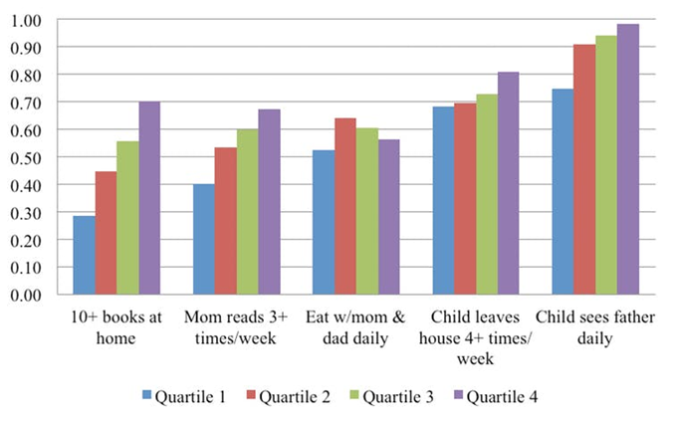
(Caucutt, 2015)

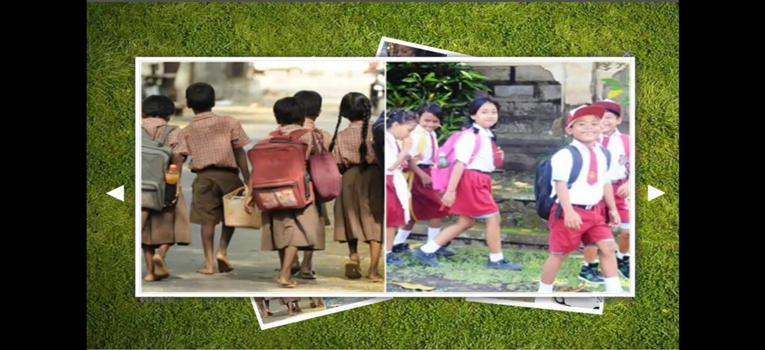
(Youtube, 2015)

References
Caucutt, E., Lochner, L., & Park, Y. (April 29, 2015). Why Do Poor Children perform so poorly. [Graph] Retrieved from https://www.cigionline.org/publications/why-do-poor-children-perform-so-poorly
Youtube,.(2015) Poor vs Rich Children [Photograph]Retrieved from https://www.google.com/search?q=images+of+poor+child+in+school+vs+rich+kids+in+school&client=firefox-b-ab&tbm=isch&source=lnms&sa=X&ved=0ahUKEwjI_PnNoLndAhWuxoUKHcOZAN8Q_AUICigB&biw=1525&bih=730&dpr=0.9#imgrc=7G3w9DZwXS92xM:

